1) Alter Table:

* Add a new column linkedin_profile to employees table to store LinkedIn URLs as varchar.

select * from employees;

Alter table employees

add column linkedinprofile varchar;

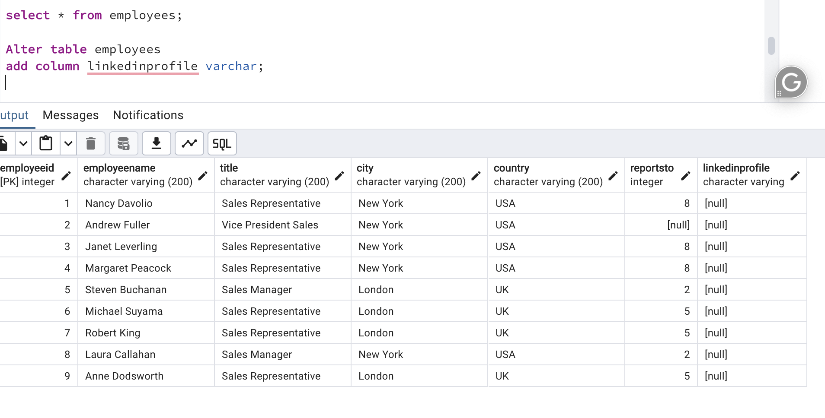

* Change the linkedin_profile column data type from VARCHAR to TEXT.

Alter table employees

alter column linkedinprofile type TEXT;

* Add unique, not null constraint to linkedin_profile

Before adding constraints as NOT NULL and UNIQUE , i m adding values into table for linkedprofile column, update that column if ts is NULL.

UPDATE employees SET linkedinprofile = 'personalCareers' WHERE linkedinprofile is NULL;

select * from employees;

Alter Table employees

alter column linkedinprofile SET NOT NULL;

ALTER TABLE employees

ADD CONSTRAINT unique_linkedinprofile UNIQUE (linkedinprofile);

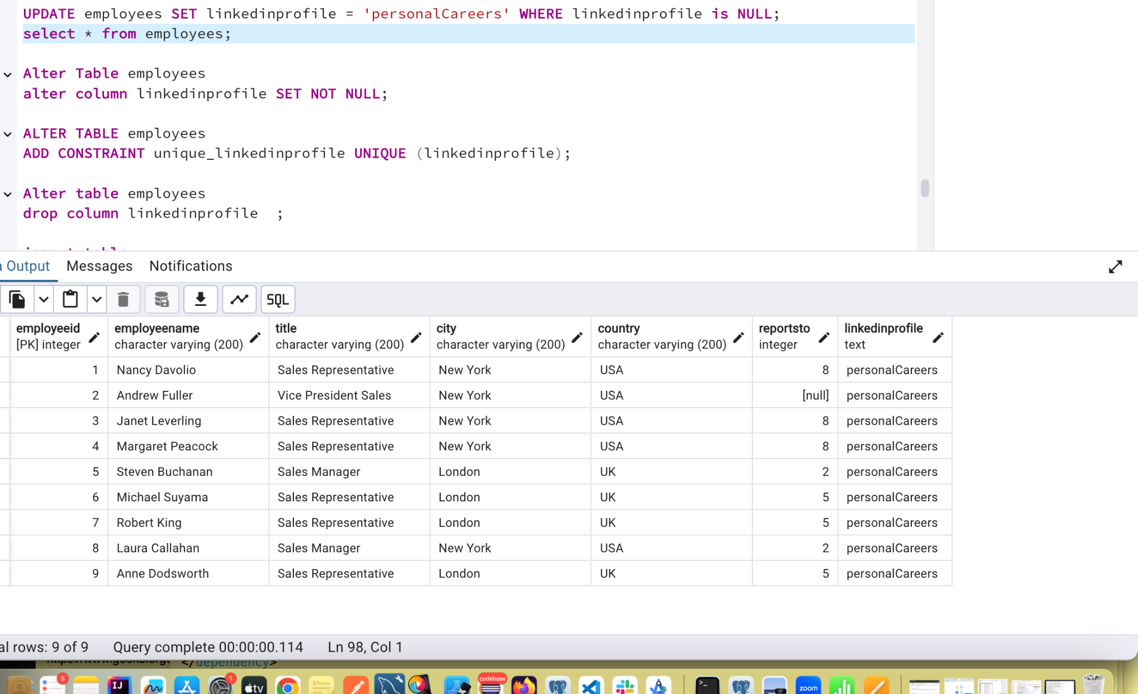

* Drop column linkedin_profile

After dropping column:

Alter table employees

drop column linkedinprofile ;

select * from employees;

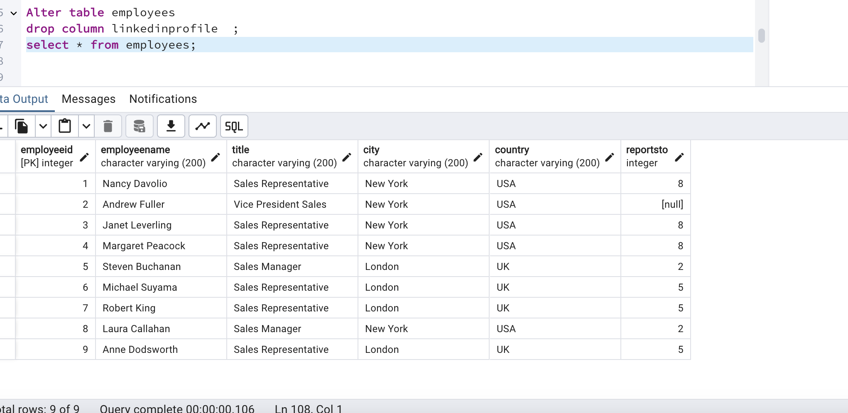

2) Querying (Select)

* Retrieve the first name, last name, and title of all employees

select * from employees;

select

split_part(employeename, ' ', 1) AS first_name,

split_part(employeename, ' ', 2) AS last_name,

title

from employees;

* 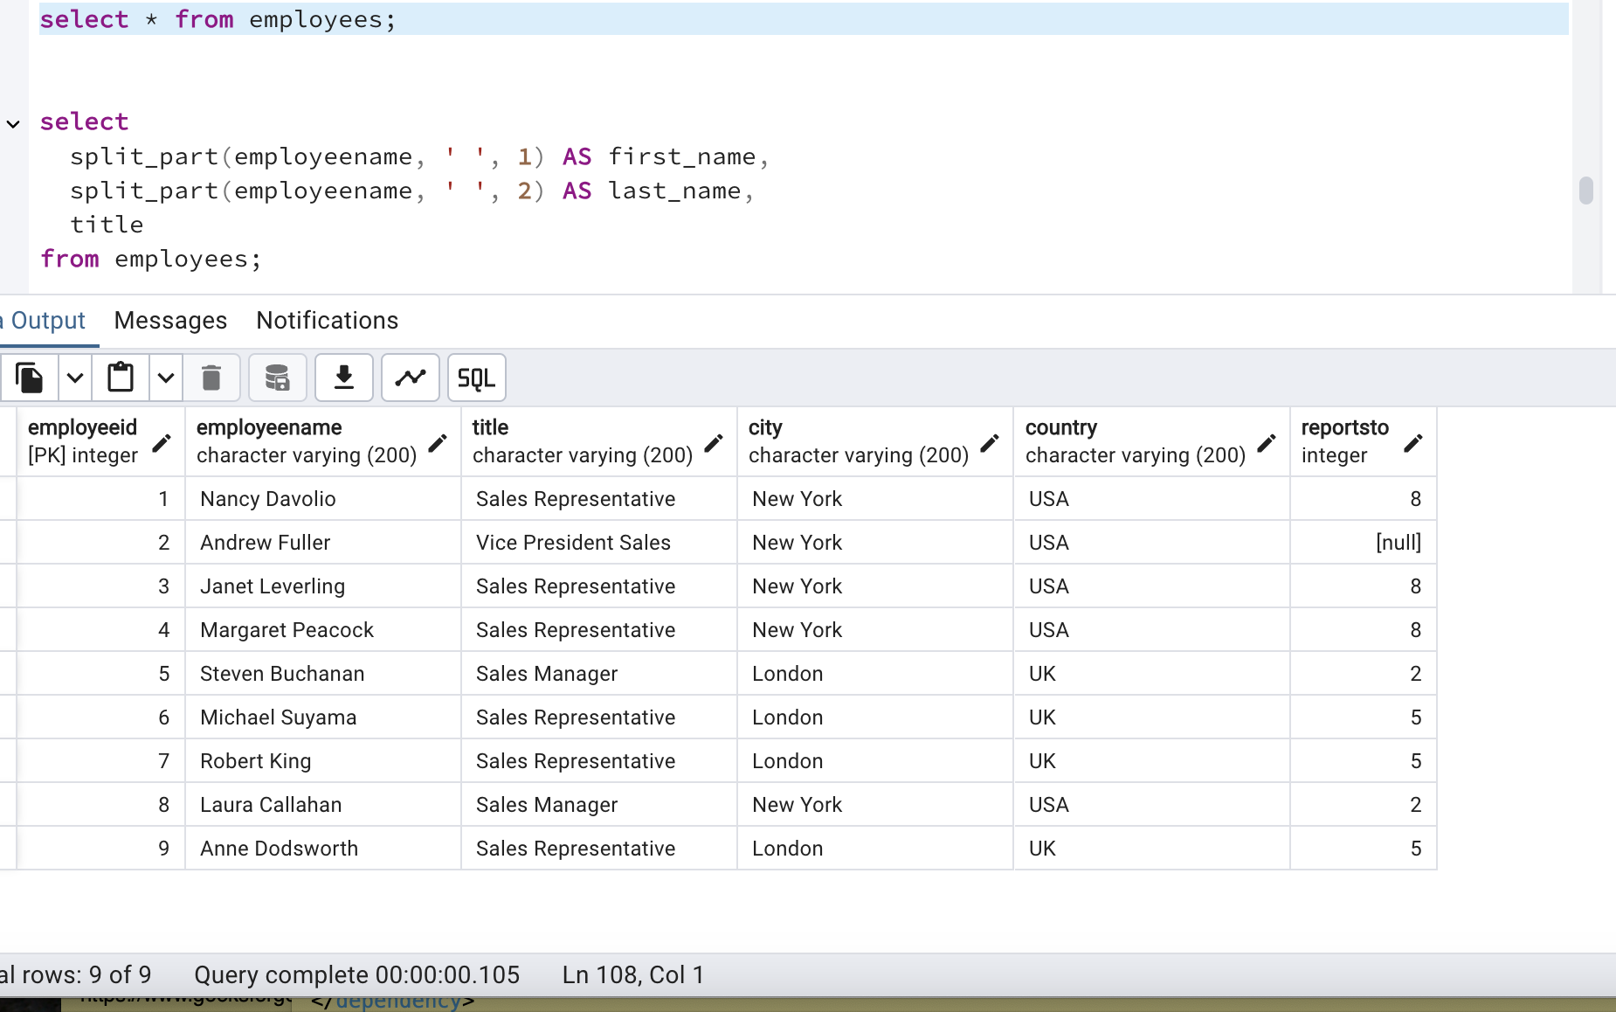

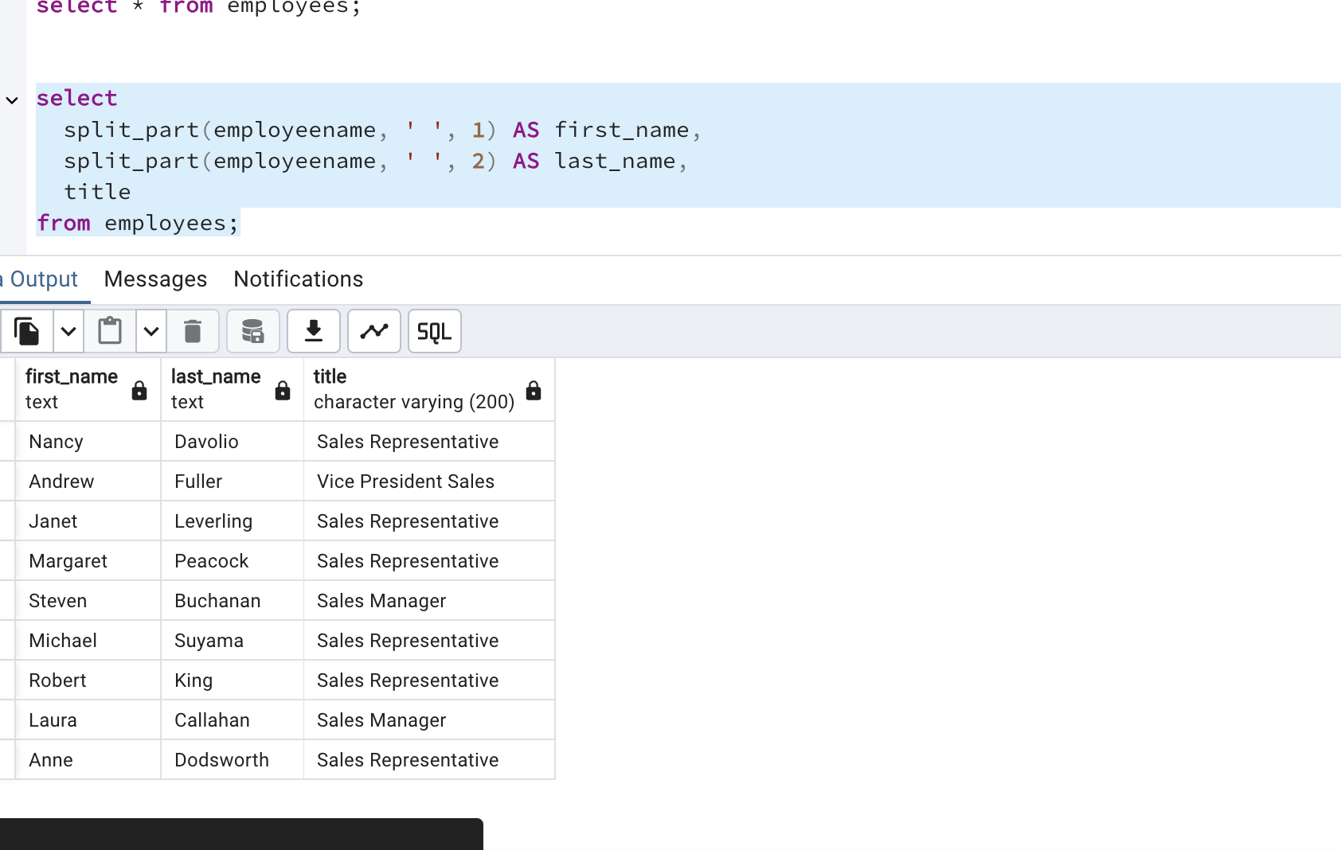

* Find all unique unit prices of products

select distinct unitprice from products;

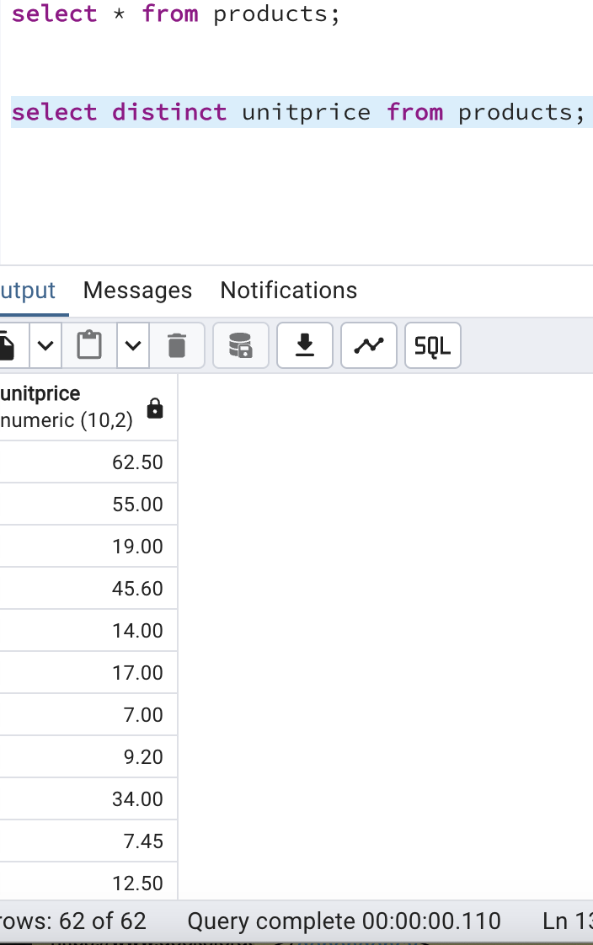

* List all customers sorted by company name in ascending order

select* from customers;

select * from customers order by companyName asc;

select * from customers order by companyName desc;

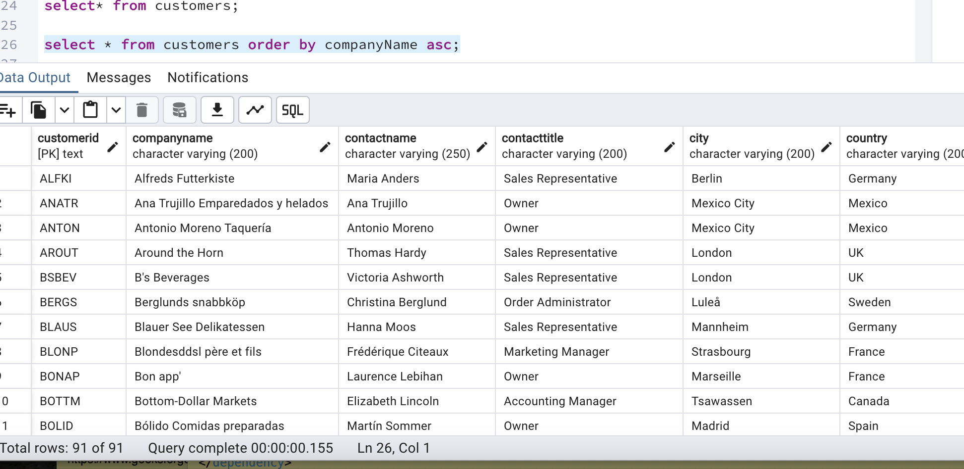

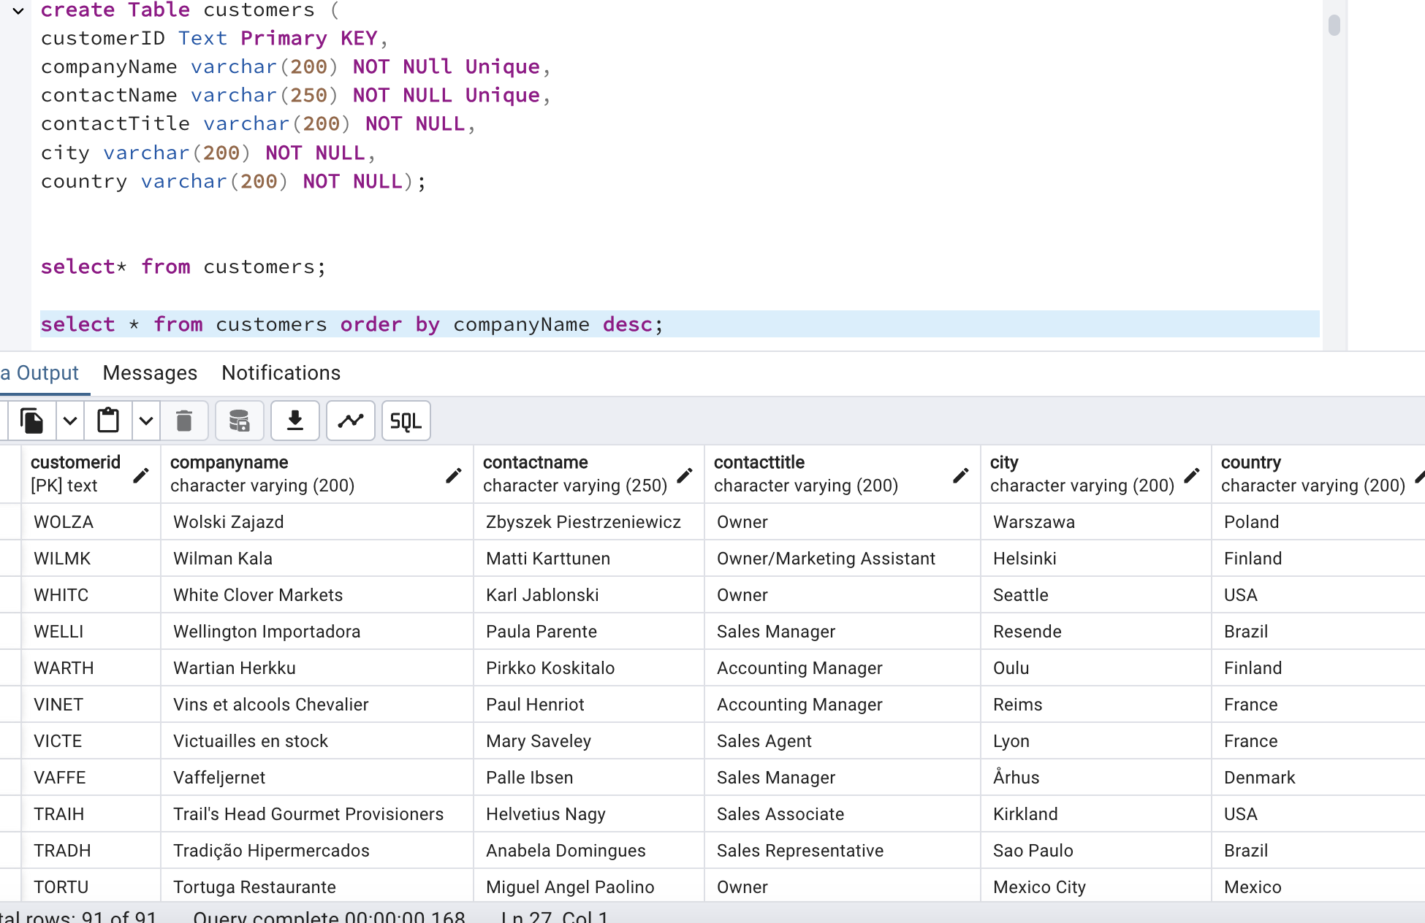

* Display product name and unit price, but rename the unit_price column as price_in_usd

select * from products;

select productname,unitprice AS price_in_usd from products;

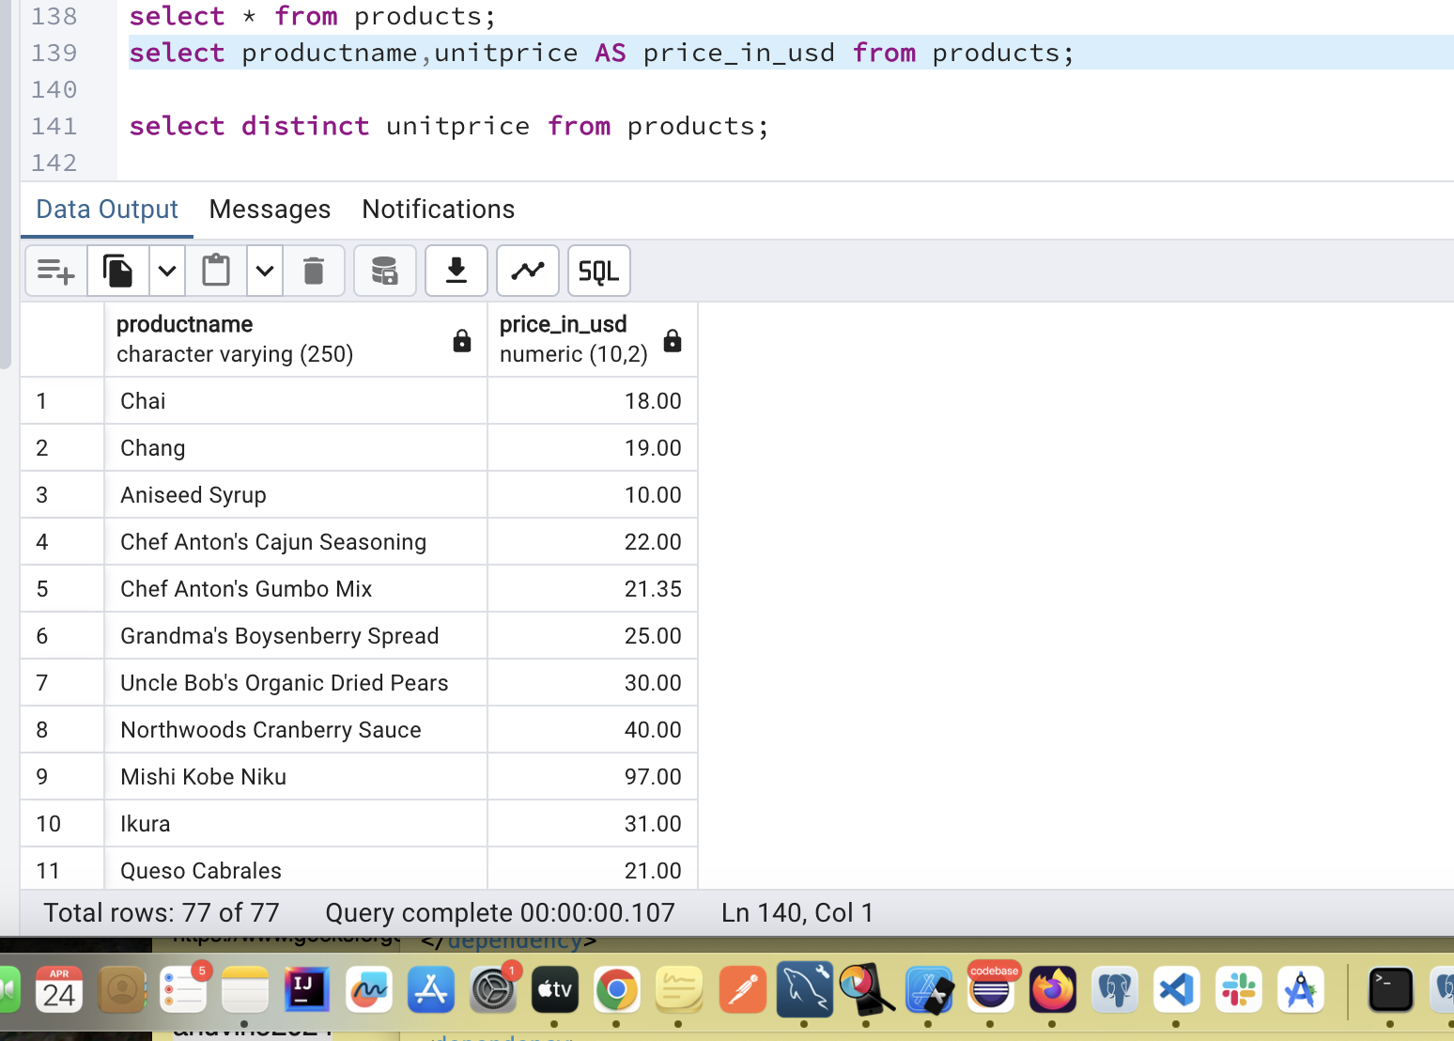

3) Filtering

* Get all customers from Germany.

select * from customers where country='Germany';

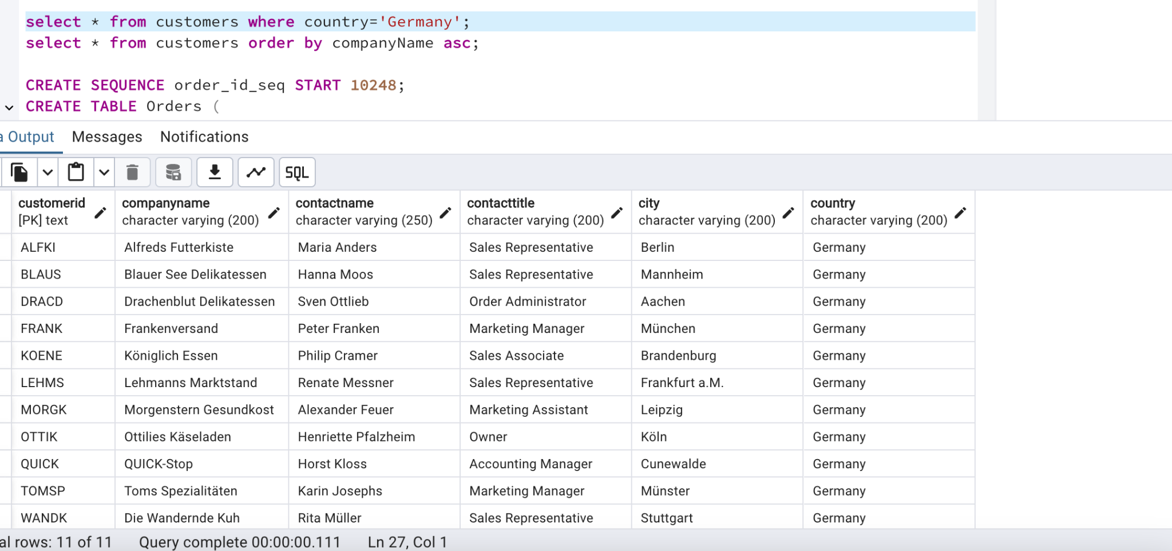

* Find all customers from France or Spain

select * from customers where country IN ('France' , 'Spain');

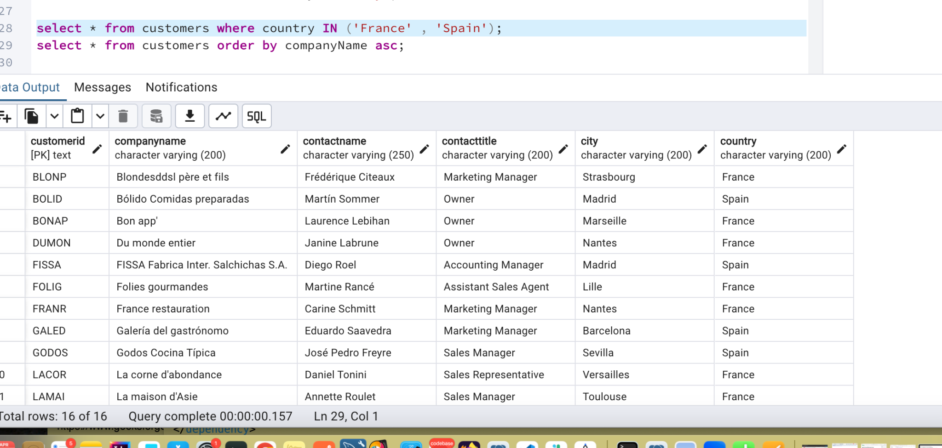

* Retrieve all orders placed in 2014(based on order_date), and either have freight greater than 50 or the shipped date available (i.e., non-NULL) (Hint: EXTRACT(YEAR FROM order_date))

Select * from Orders;

select * from orders where EXTRACT(YEAR FROM orderdate) ='2014' and

(freight>50 or shippeddate is NOT NULL );

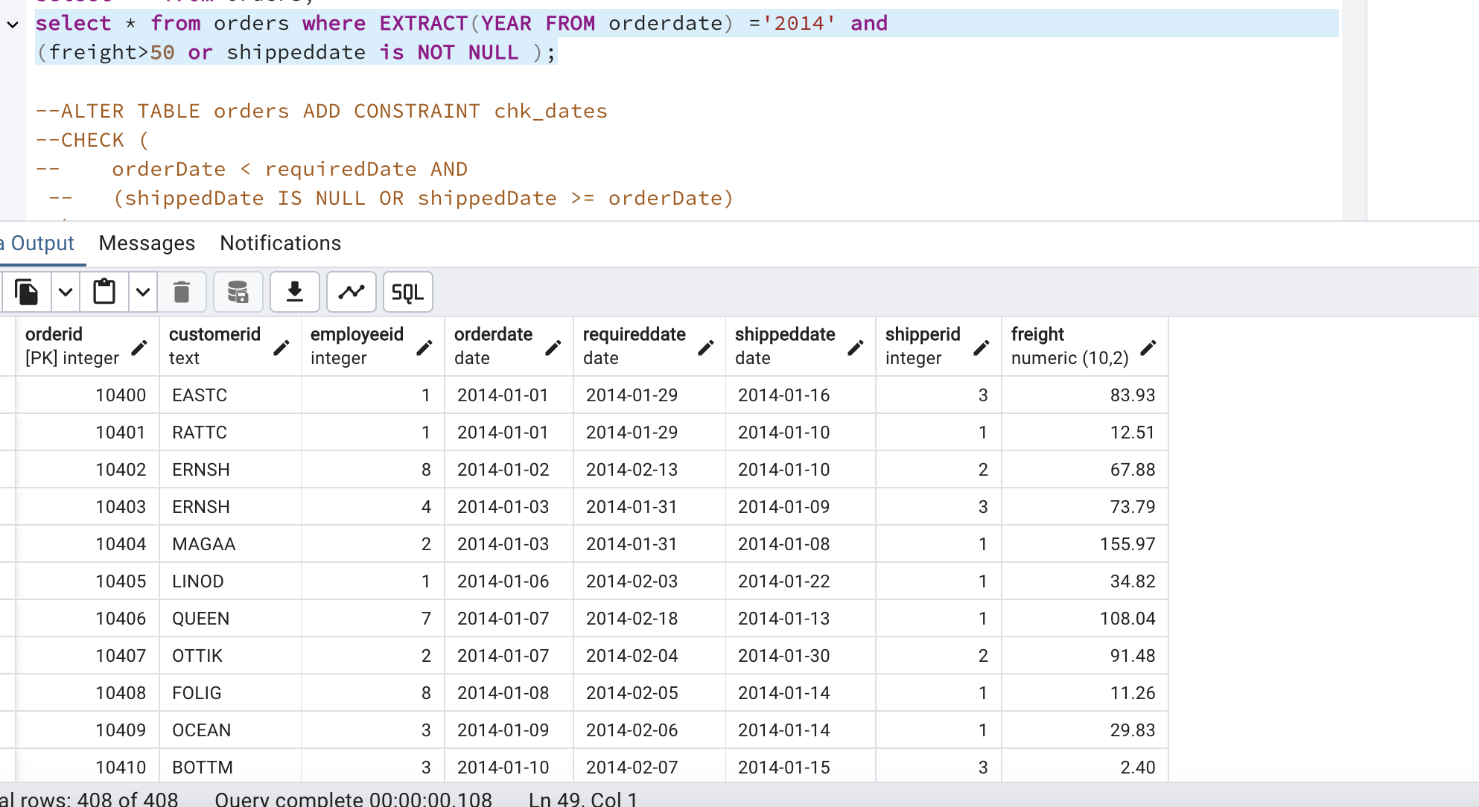

4) Filtering

* Retrieve the product_id, product_name, and unit_price of products where the unit_price is greater than 15.

select productid,productname,unitprice from products where unitprice > 15;

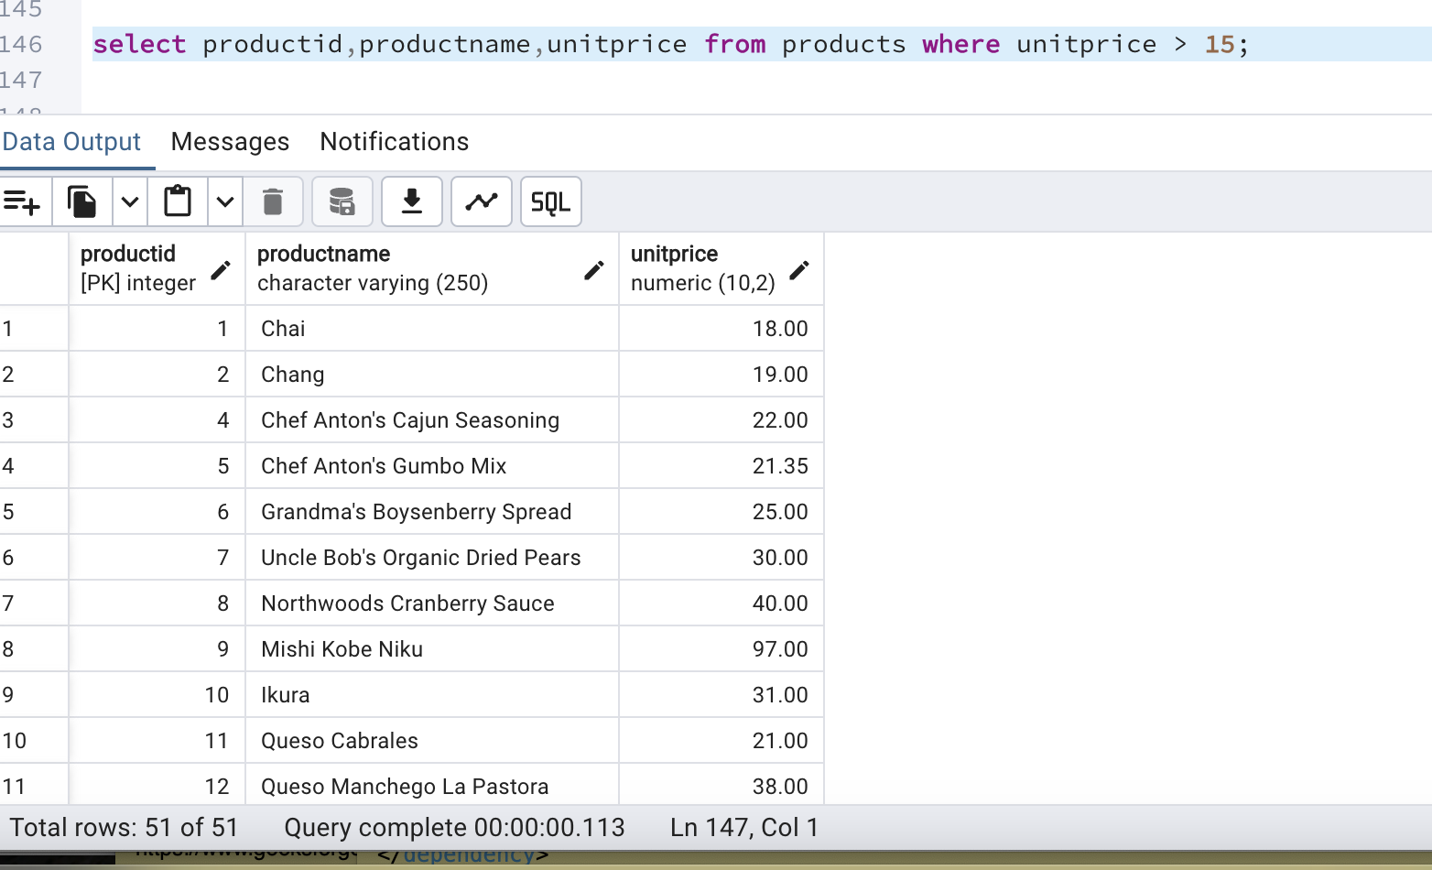

* List all employees who are located in the USA and have the title "Sales Representative".

select * from employees where country ='USA' and title='Sales Representative';

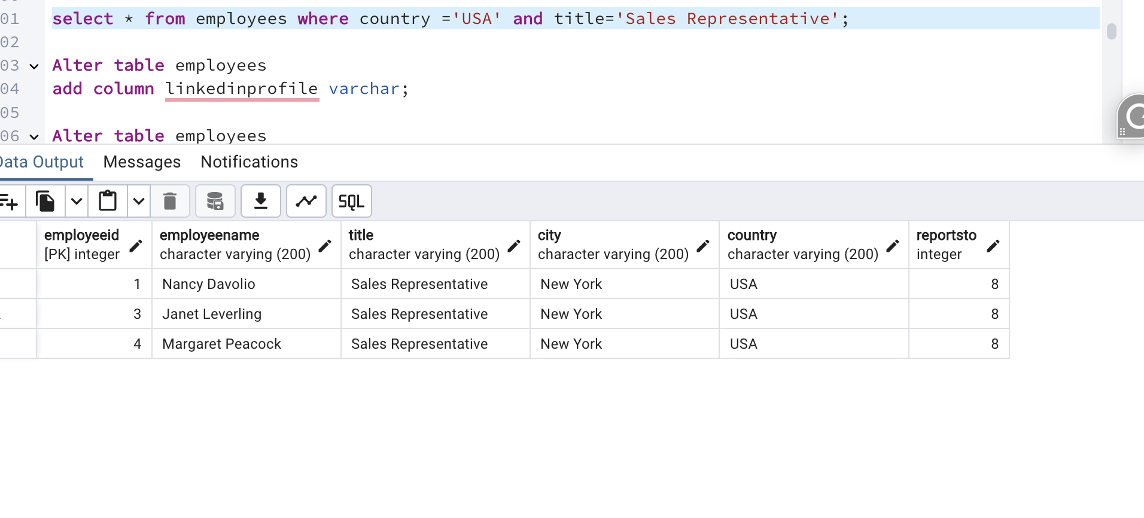

* Retrieve all products that are not discontinued and priced greater than 30.

select * from products where discontinued=0 and unitprice> 30;

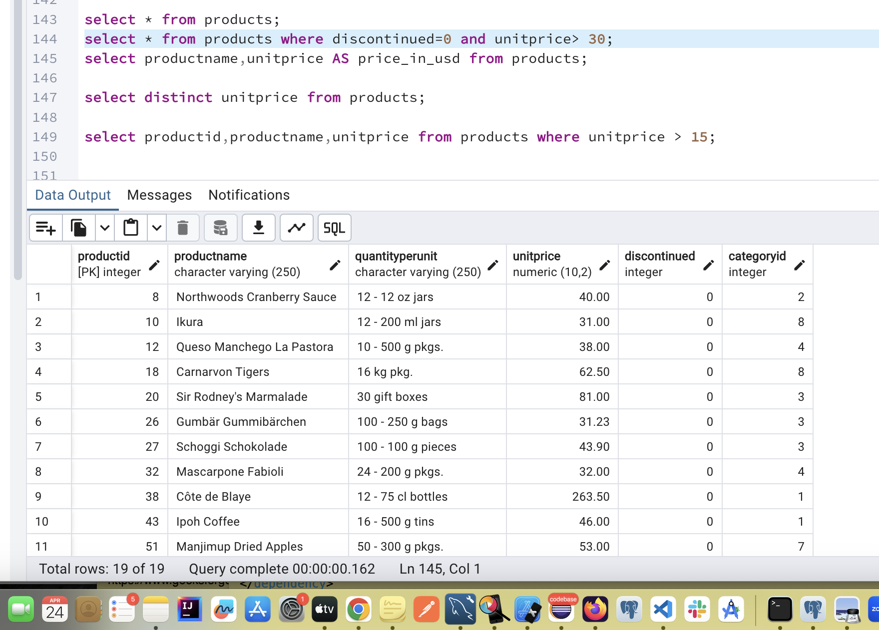

5) LIMIT/FETCH

* Retrieve the first 10 orders from the orders table.

select * from orders order by limit 10;

select * from orders order by orderid limit 10;

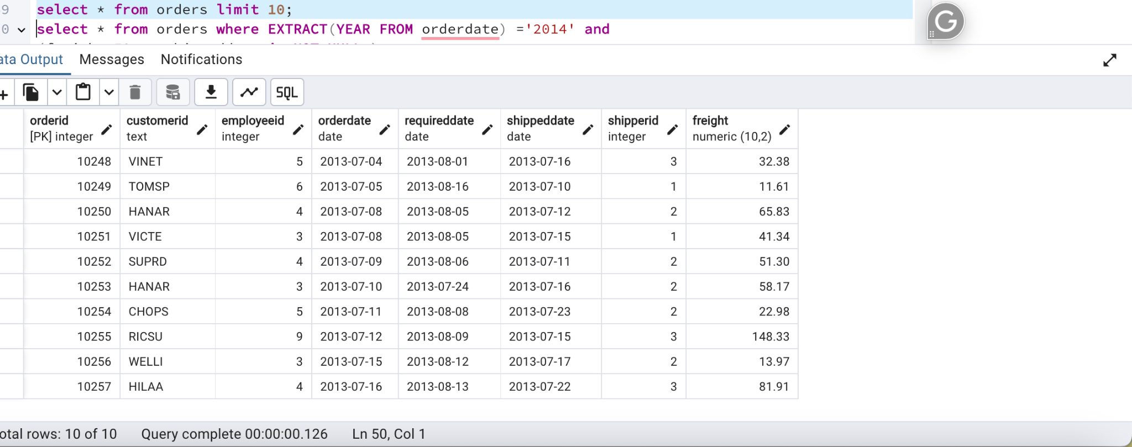

* Retrieve orders starting from the 11th order, fetching 10 rows (i.e., fetch rows 11-20).

select * from orders order by orderid offset 10 fetch next 10 rows only;

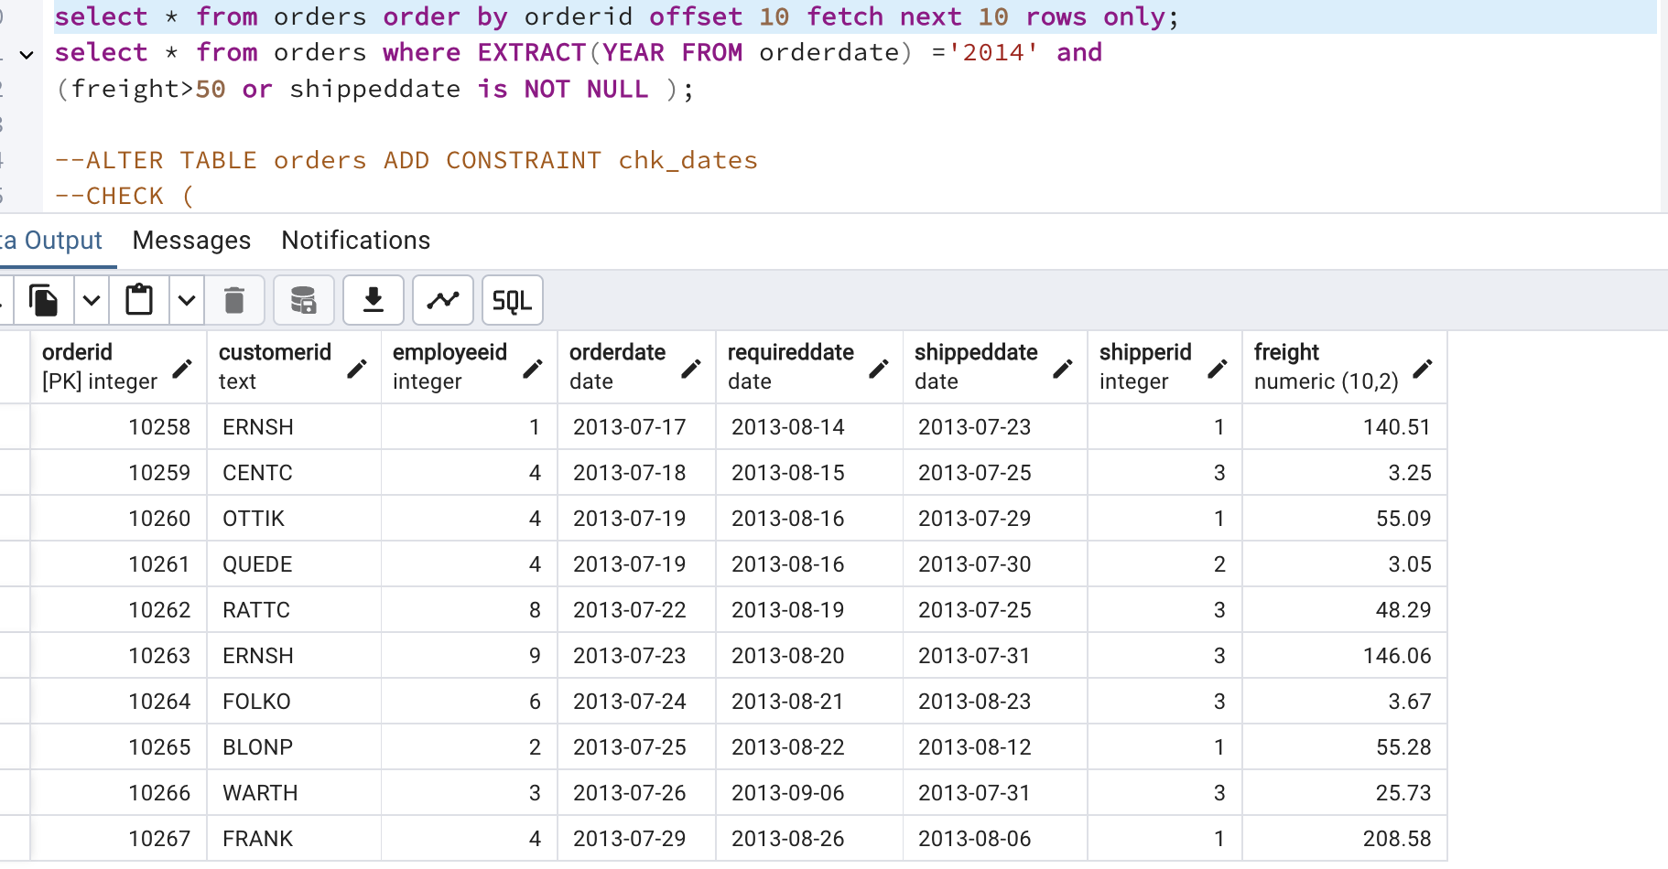

6) Filtering (IN, BETWEEN)

* List all customers who are either Sales Representative, Owner

select * from customers where contacttitle in ('Sales Representative','Owner');

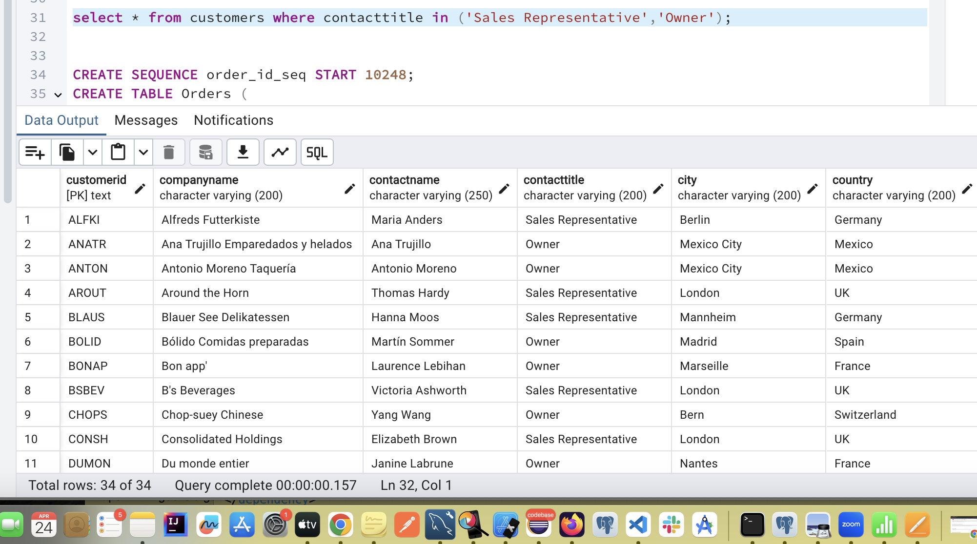

* Retrieve orders placed between January 1, 2013, and December 31, 2013.

select * from orders where orderdate between '2013-01-1' and '2013-12-31';

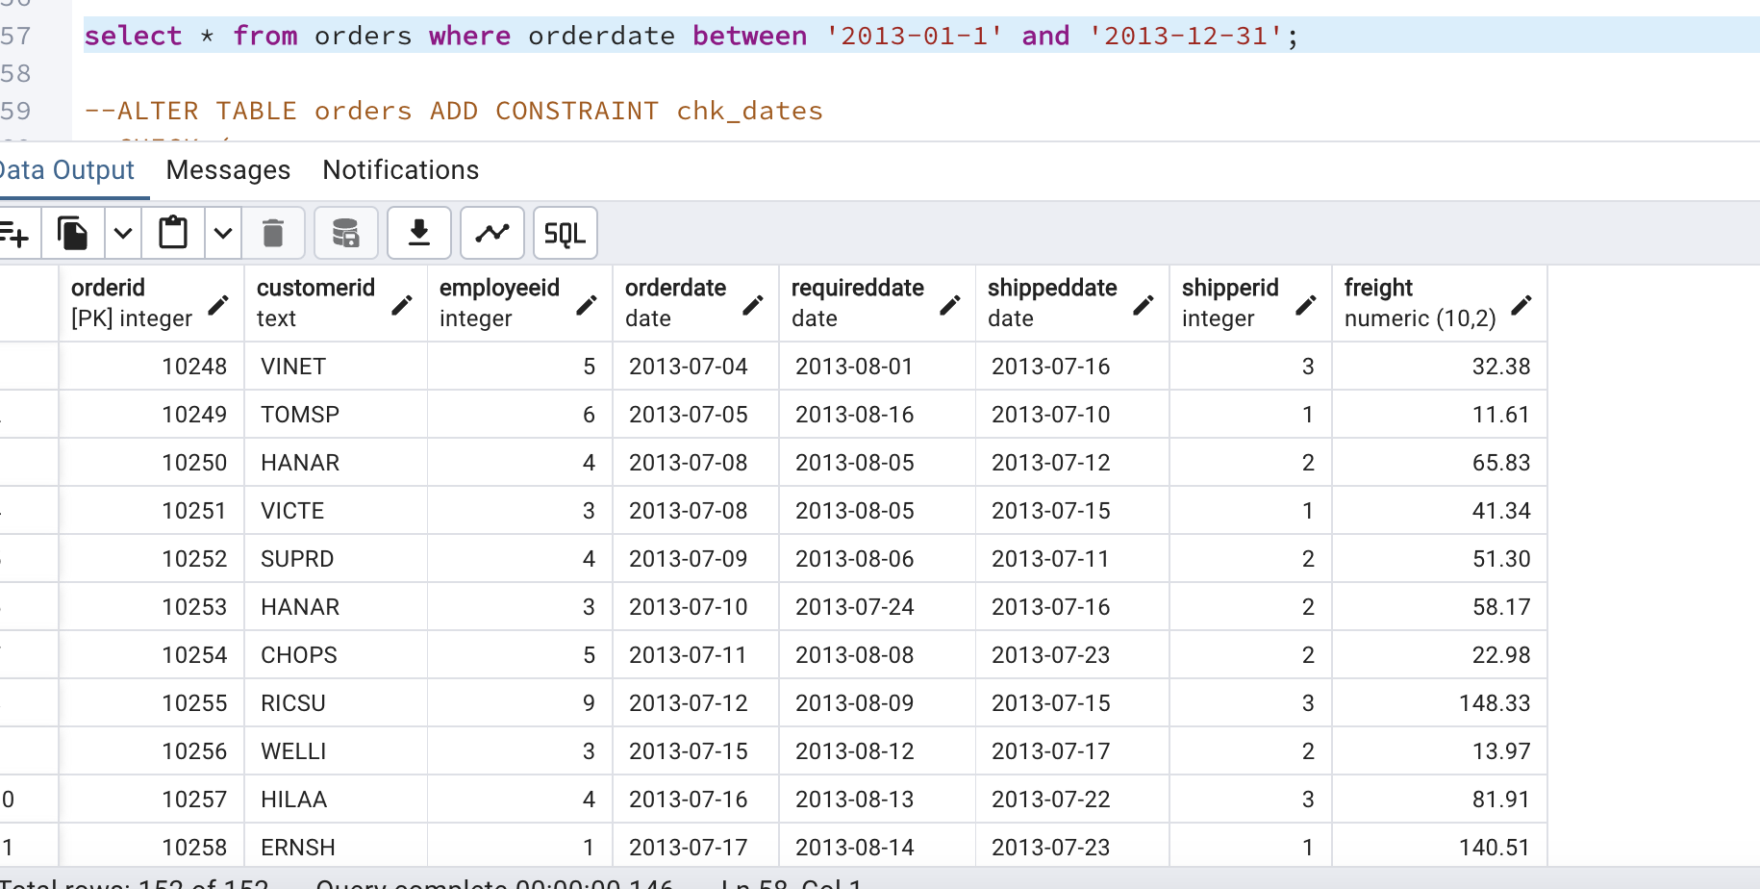

7) Filtering

* List all products whose category_id is not 1, 2, or 3.

select * from products where categoryid NOT in ('1','2','3');

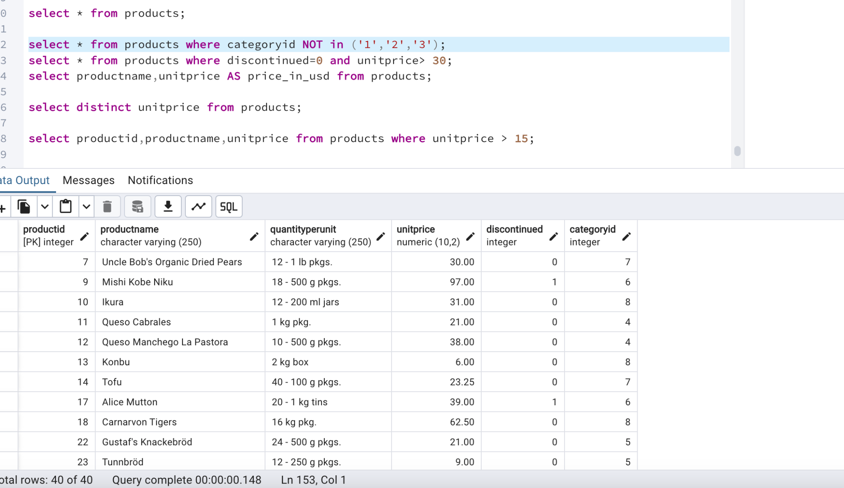

* Find customers whose company name starts with "A".

select * from customers where companyname like 'A%';

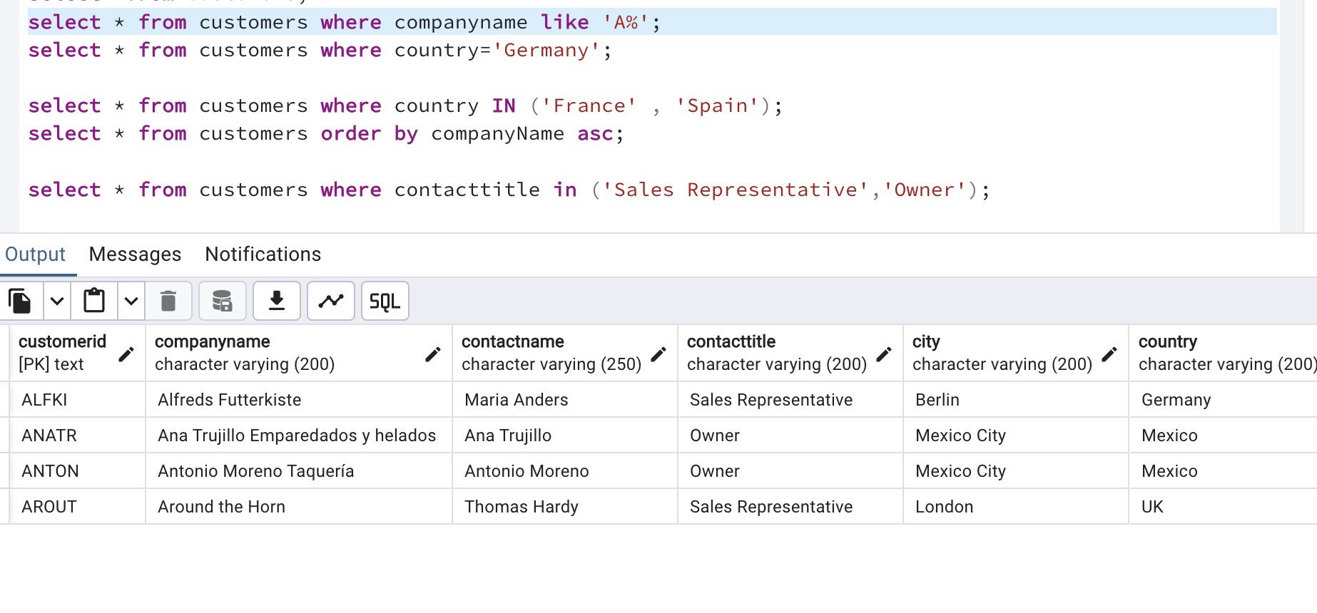

8) INSERT into orders table:

Task: Add a new order to the orders table with the following details:

Order ID: 11078

Customer ID: ALFKI

Employee ID: 5

Order Date: 2025-04-23

Required Date: 2025-04-30

Shipped Date: 2025-04-25

shipperID:2

Freight: 45.50

insert into orders (orderid,customerid,employeeid,orderdate,requireddate,shippeddate,shipperid,freight)

values (11078,'ALFKI',5,'2025-04-23','2025-04-30','2025-04-25',2,45.50);

Select * from Orders where orderid='11078';

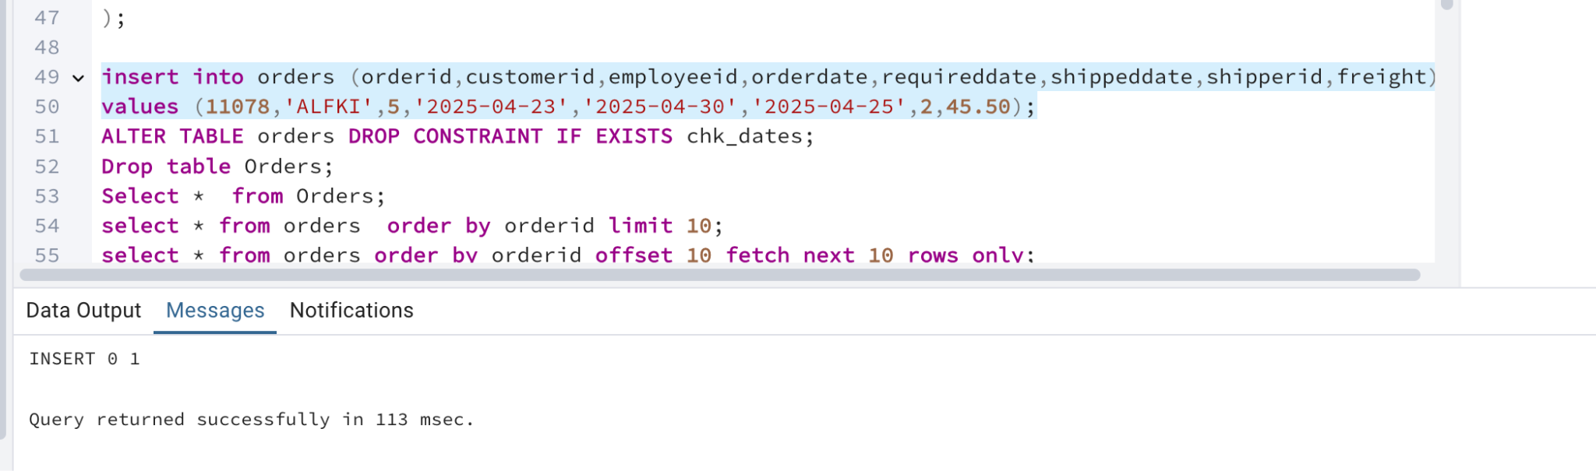

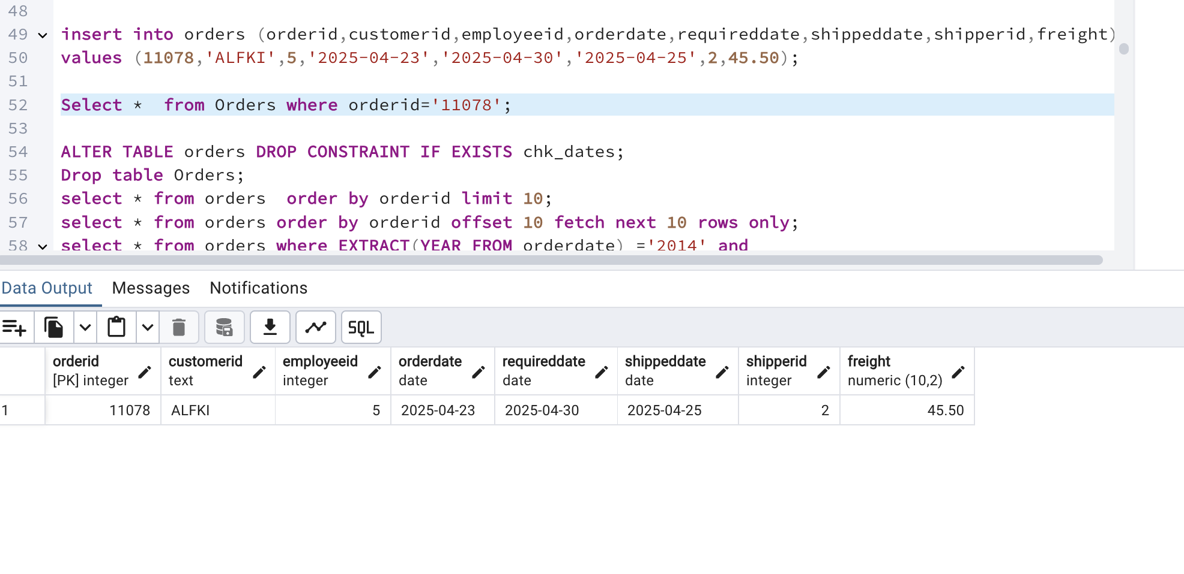

9) Increase(Update) the unit price of all products in category_id =2 by 10%.

(HINT: unit_price =unit_price * 1.10)

update products set unitprice =unitprice * 1.10 where categoryid= 2;

select * from products where categoryid=2;

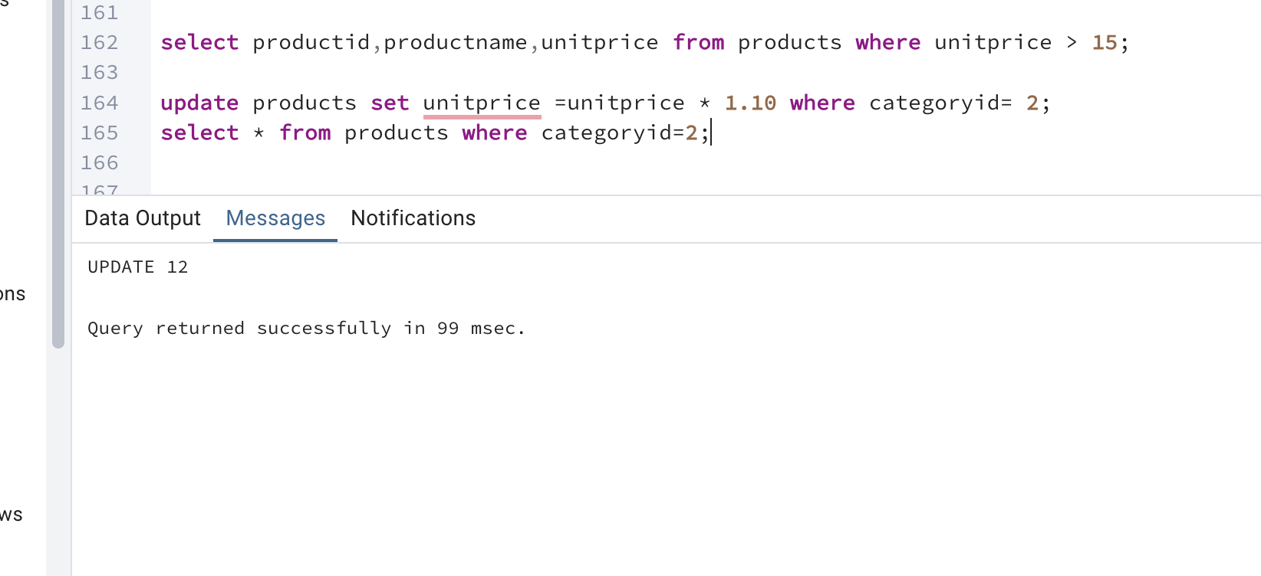

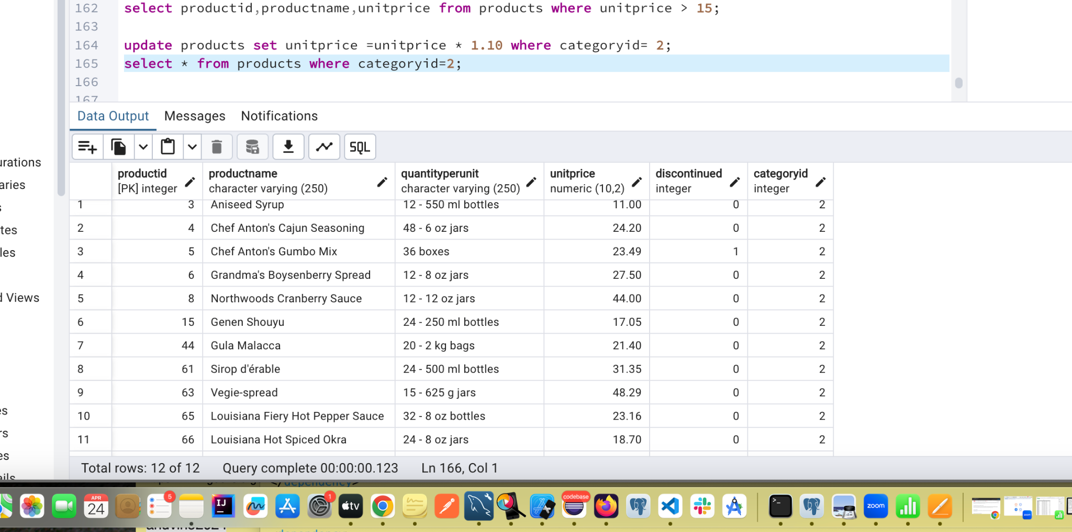

10)Sample Northwind database:

Download done and 14 tables are added

